# React

# ReactJS-HOL

# Mandatory HandsOn

Create a React Application named “cricketapp” with the following components:

npx create-react-app cricketapp

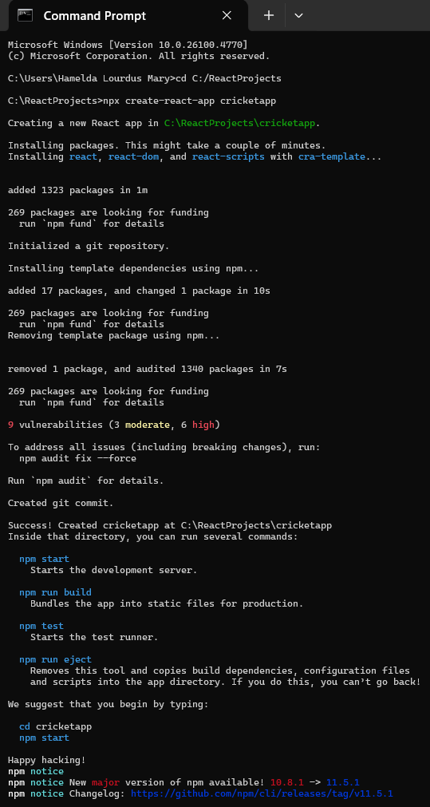

**ListOfPlayers:**

function ListOfPlayers() {

    const players = [

        { name: 'Jack', score: 50 },

        { name: 'Michael', score: 70 },

        { name: 'John', score: 40 },

        { name: 'Amin', score: 61 },

        { name: 'Elisabeth', score: 61 },

        { name: 'Sachin', score: 95 },

        { name: 'Dhoni', score: 100 },

        { name: 'Virat', score: 84 },

        { name: 'Jadeja', score: 64 },

        { name: 'Raina', score: 75 },

        { name: 'Rohit', score: 80 }

    ];

    // Filter players with scores below 70 using arrow function

    const playersBelow70 = players.filter(player => player.score <= 70);

    return (

        <div>

            <h2>List of Players</h2>

            <ul>

                {players.map((player) => (

                    <li>

                        Mr. {player.name} {player.score}

                    </li>

                ))}

            </ul>

            <hr />

            <h2>List Of Players having Scores Less than 70</h2>

            <ul>

                {playersBelow70.map((player) => (

                    <li>

                        Mr. {player.name} {player.score}

                    </li>

                ))}

            </ul>

        </div>

    );

}

export default ListOfPlayers;

**IndianPlayers.js**

// Display Odd Team Player using Destructuring

export function OddPlayers([first, , third, , fifth]) {

    return (

        <div>

            <li> First : {first} </li>

            <li> Third : {third} </li>

            <li> Fifth : {fifth} </li>

        </div>

    );

}

// Display Even Team Player using Destructuring

export function EvenPlayers([, second, , fourth, , sixth]) {

    return (

        <div>

            <li> Second : {second} </li>

            <li> Fourth : {fourth} </li>

            <li> Sixth : {sixth} </li>

        </div>

    );

}

const T20Players = ['First Player', 'Second Player', 'Third Player'];

const RanjiTrophyPlayers = ['Fourth Player', 'Fifth Player', 'Sixth Player'];

export const IndianPlayers = [...T20Players, ...RanjiTrophyPlayers];  // Merged array

export default function ListofIndianPlayers({ IndianPlayers }) {

    return (

        <div>

            {IndianPlayers.map((player, index) => (

                <li key={index}>Mr. {player}</li>

            ))}

        </div>

    );

}

**Output:**

cd cricketapp

npm start

When Flag= True

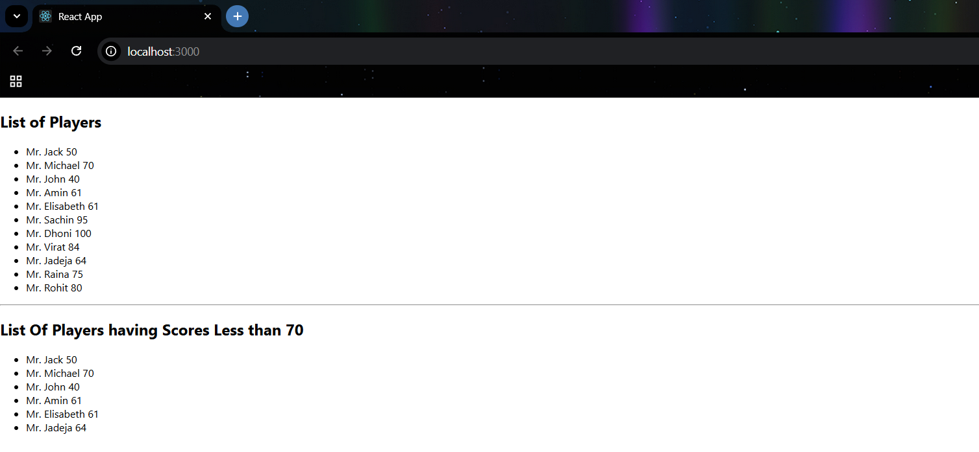

When Flag=false

